Change Game: Facilitators evaluation sheet

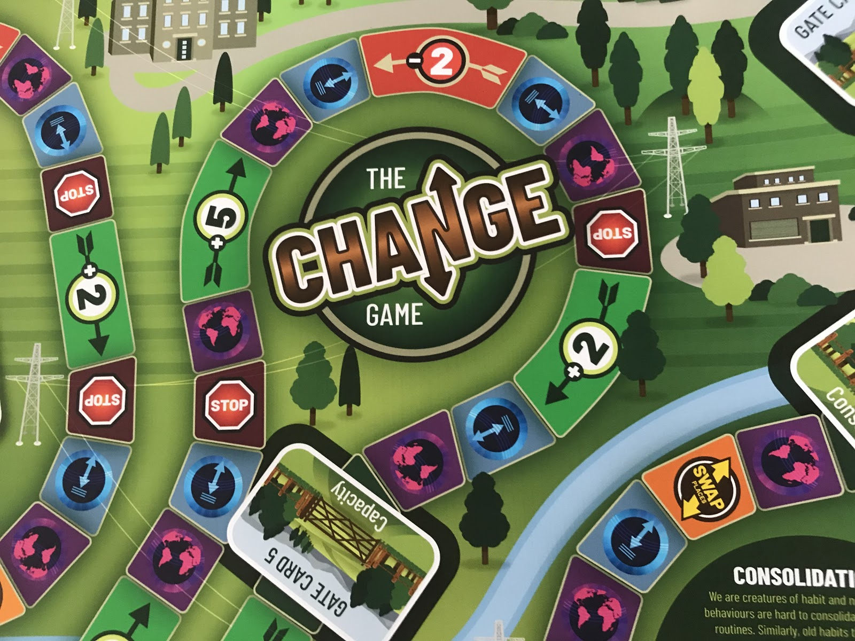

This evaluation form is for use between period 01 March to 09 October 2020
to enable an MSDP report back to the SDF Conference in November 2020

Please note this is an evaluation report and not a research project.

Firstly, we hope that you found playing the Change Game a productive learning event for your staff.

It was purchased (cost £720) via an SDF Regional Funding Grant and part of the conditions of the grant is to produce an evaluation report back to the SDF.

The purpose of the report will be to share our learning experiences of playing the Change Game to the wider SDF community.

This evaluation is designed to be completed by the host MSDP member who requested the game.

Once completed. Please return a copy of the evaluation report to,

Ian Whiting MSDP Chair. Email: iwhiting@brookes.ac.uk

Change Game: Facilitators evaluation sheet
(Type to expand out the boxes)

University
MSDP Member
Dates game played

Section 1: Your context for playing the change game(s). Please tell us about
- Your reasons and context for playing the game.
- The participant groups, how many, where from, general makeup of the group?

Section 2: Playing the change game(s).
Please tell us what happened, how straightforward was it to set up, how was it playing the game, any observations, how long did it take, did a team get to the finish?

Section 3: Collated feedback from participants playing the game.
Please collate and share any feedback from evaluation you carried out with participants

Section 4: Your observations / reflections on participants playing the game. Please share your observations with regard to the effectiveness of using gameplay as a learning intervention.

Section 5: Future applications for playing the change game.
Please share with us your views on the potential future applications of use for the Change Game?

Section 6: Any other insightful feedback to benefit the SDF Community.

Thank you for completing this evaluation report.

Once completed. Please return a copy of the evaluation report to,

Ian Whiting MSDP Chair. Email: iwhiting@brookes.ac.uk

