First Impressions –
Team development in service delivery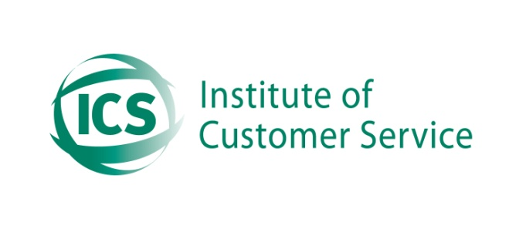

UWE joined the Institute of Customer Service (ICS) in August 2011, we signed up for 4 years as part of the initiative to improve the customer focus and culture to put students at the heart of the system. Initially the professional services will be the start point for this cultural change, it is intended to deliver a consistent quality approach and understanding that we are now dealing with sophisticated customer interactions in the Education sector.

The intention is to provide training in professional service delivery using accredited programmes that are challenging but also rewarding to participants and foster collaborative team approaches to service excellence.

Why are we doing this training?

- Provide staff with the tools to deliver first class service to students and staff
- Create a consistent approach for service excellence across all professional services
- Develop a culture of customer led change and continuous improvement
- Improve satisfaction rates for professional services to 90% for service delivery
- Understand the ‘power of the team’ approach to service and problem resolution

What does it involve?

Groups of 15 staff per session
2.5 days of training, 2 days in interactive training
A 500 word assignment
Accredited course with the ICS
Each module assessed with multiple choice
A workbook approach that is retained by trainee
A 1 day workshop for managers and team leaders

What are the implications on the function?

- Mentoring by line manager for the assignment
- Scheduling of staff release
- Importance of idea generation from the assignment and potential implementation
- Cultural change – (putting the student at the heart of the system)
- Team leader/manager workshop, 1 day to prepare for staff training

The main business areas covered by the training:

- The fundamental concepts of customer service
- Developing relationships with customers
- Communicating effectively
- Delivering service excellence through team work
- Responding to Customers
- The ‘you’ factor

How do staff (trainees) benefit from this?

- They receive accredited professional training from the institute providers
- A Certificate of attainment following successful assignment completion and pass mark success. (recognised nationally)
- Membership of the institute for 1 year with customer first membership magazine
- Access to members meetings/events and ICS web site
- Regular newsletters, access to publications
- Better equipped to handle the challenging environment they operate in

How will UWE benefit from this?

- Closer alignment to customer needs and insight into future development of the University
- Significantly improved satisfaction rates from students and internal customers circa (90%) satisfaction levels
- Enhance the one university approach and cultural desire through cross functional teamwork
- Competitive advantage with improved retention levels from students
- A competent motivated team delivering excellent customer service
- Measuring the right things, using this to enhance and develop the services

When will this start, how many people will benefit?

The training is expected to start with a pilot session in April 2012, this will be adjusted if necessary before the roll out to all 150 staff takes place over a 2-3 month period.

A workshop for the team leader/managers will take place for approx 30 people in total prior to the pilot and will prepare them for the expected support and encouragement to their staff to complete the assignment and handle the ideas generated from this process. The assignments are based around the workplace.

The pre set topics for the assignments can be altered but they are:

- First impressions count
- Improving a customer service questionnaire
- A complaint is a gift
- Improving communications in your organisation

Pre work

Trainees - There will be some pre work prior to the course starting and each trainee will be expected to register and complete some questions around what they do, what they may want to get out of the training etc.

University – identification of the customer environment, competition, examples relevant to Universities, complaints process, current satisfaction levels and benchmarking, vision and strategy for customer service.

Summary:

UWE is serious about the intention to improve and provide students with excellent service and equip staff with the tools to achieve this attainment. This is part of a cultural change required to provide UWE with a competitive advantage over other similar education establishments and is a key element in moving the new services forward.

This training is about enhancing professional behaviour and practices in the work place with a focus on customers and colleagues, but provides techniques and tools that can be used anywhere.

